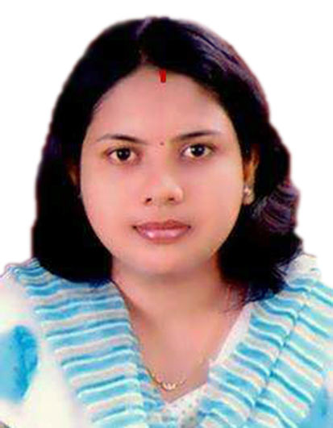
DEEPANJALI MUDULI

Mobile: 9668442068

E-Mail: deepanjali.muduli@gmail.com

Present Package: 3.00 lakhs per Annum
Expected Package: Negotiable
Preferred Location: Bhubaneswar

Career OBJECTIVE:
To work in a growth oriented challenging jobs and grows long with the growth of organization by using my technical skills up grade knowledge and Implement the same for Improvement of working organization.
WORKING EXPERIENCE 1:
Working as Centre Head in Govt. Of India Skill development Project i.e. DDU GKY Project from January 2016 to till date.
Responsibilities are:
- Ensuring proper and regular running of training program with 200 capacities of Trainees.
- Making arrangements for boarding & lodging facility at the centre.
- Ensuring the quality of the facilities provided at the training centre as per guide line and also arranging Industrial visit of trainees for their exposure.
- Managing documentation regarding details of students and also other
documents pertaining to financial relevance.
- Doing MIS work, maintaing stock details of training centre, look after of all equipments of training centre.
- Submitting regular training information to State Coordinator.
- Regularly interacting with students motivates them and takes feedback on the training.
- Made reports to State Coordinator in daily.
- Guide (coordinate with) the field mobilizer for mobilization of batch.
- Guide (coordinate with) the Placement Officer for batch wise placement and retention.
- Regular follow up from all staffs for mobilisation, training, placement, tracking, retention & career progression etc.
- Coordinating with Inspecting officers, deligators, Community Cadres who are coming for inspection, rating & grading purpose and visiting purpose.

WORKING EXPERIENCE 2:
- Working as Administrative Officer in Saswata Group (RJ School of Management Studies) January 2015 to December 2015.
RESPONSIBILITIES:
- To recruit, Lecturers, Office executive & Marketing Manager, Tele caller, Counselor and also taking interview.
- Preparing salary structure of all the college employees.
- Controlling all the students & staffs.
- If there was any problem arised from student & also from staff’s side immediate proper action & decision was taken by me.
- To Ensure Proper Communication with regular follow up with College staff.
- Daily reporting to Director.
- To organize meetings between Parents and Director.
- And also involved in admission by using Electronic media, paper advertisement.
- Maintain the good relationship between with Parents, Students & all official staffs.
WORKING EXPERIENCE 3:
- Working as Administrative Officer in NM Technology Ltd from February 2013 to April 2015.
RESPONSIBILITIES:
- To recruit, Software developers & Marketing Manager, Development Officer and also taking interview.
- To Ensure Proper Communication with regular follow up with Software developers.
- Daily reporting to Managing Director.
- To organize meetings between Client and Development Officers.
- To demonstrate, advertisement and documentation of the programs.
- Maintain the good relationship between with the suppliers & all official staffs.
WORKING EXPERIENCE 4:
- I was working on .NET(C#,ASP) platform as Software Developer in Embest Info Solution from January 2009 to January 2012.
PROJECTS:
PROJECT:
Project Name: EMINUTES
Group Member: 4
Client: Idcol Software Ltd
Technology used:
1. Front End:
C#.NET USING ASP.NET TECHNOLOGY
2. Back End:
SQL SERVER 2005
3. Client Operating System:
WINDOWS XP
4. Server Operating System:
WINDOWS 2000 SERVER
Project Details:
The concerned project is developed for IDCOL which is a subsidiary company of Govt. of Orissa. Under IDCOL various companies are currently working, namely IKIWL, IFCAL, KJL, ISL, ABSSOLSNCL and IPEWL. Along with it has a corporate office which is at Bhubaneswar, it has also various number of departments and each department is controlling different companies its same department job.
The control of the above jobs and for company improvement, in every three months interval, they are arranging a Board Meeting. In each meeting, various topics are being discussed and finally minutes are generated. The copy of the minutes is then sending to the concerned department by judging to which department that concerned minutes belongs.

PROFESSIONAL QUALIFICATION:
- Passed B.Tech from BPUT, Orissa, specialization in Applied Electronics & Instrumentation Engineering in the year 2008 with CGPA 7.10 .

ACADAMIC QUALIFICATION:

- Passed HSC from BSE, Orissa, in the year 2001 .
- Passed +2 Science from CHSE, Orissa, in the year 2003 .
- TECHNICAL SKILLS:
- OPERATING SYSTEMS : Windows OR Windows XP, Vista
- PROGRAMMING LANGUAGES: C, C++, VB .NET, C#.NET
- WEB TECHNOLOGIES : HTML, ASP.NET
- RDBMS : SQL Server
- REPORTING TOOLS : MS Data Reports, Crystal Reports

ACHIEVEMENT:

- Achieved Scholarship in 5th standard
- Winner in science exhibition on “PRODUCTION OF ELECTRICITY FROM BIO GAS” in school level competition.
- Five times 1st prize Winner in Debate, Essay competition at school & college level
- Participated in “SUDH ORIYA LIKHAN” Contest and was awarded.

COMPETENCIES

- Sincere, Devoted to work, Efficient
- Hardworking, Confident &punctual
- Good Team Player & Team motivated
- Ability to manage daily workflow

PERSONAL DETAILS:

Father’s Name : Hemanta Kumar Muduli
Address : At- Sundarpada,
Behind Kapila Prasad Govt. High School
Bhubaneswar-751002
Dist. - Khurda (Orissa)
Date of Birth : 14th July 1986
Sex : Female
Marital Status : Married
Category : General
Nationality : Indian
Religion : Hinduism

DECLARATION:

All the information furnished above is true to the best of my knowledge & believe and at the same time I assure you the confidence of my capability to the best way possible.

Place: Bhubaneswar

Date:06-03-2020 Deepanjali Muduli

