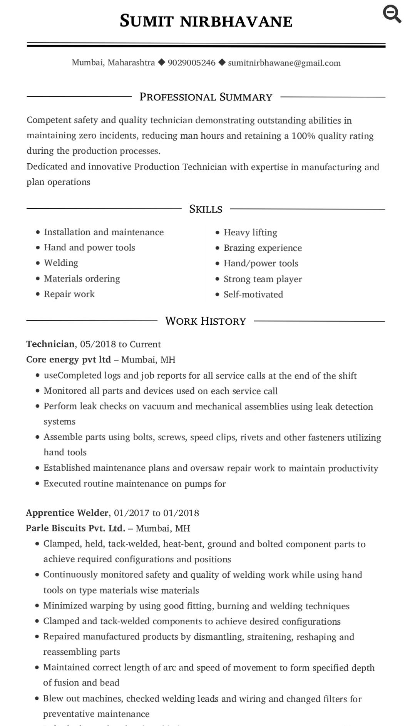
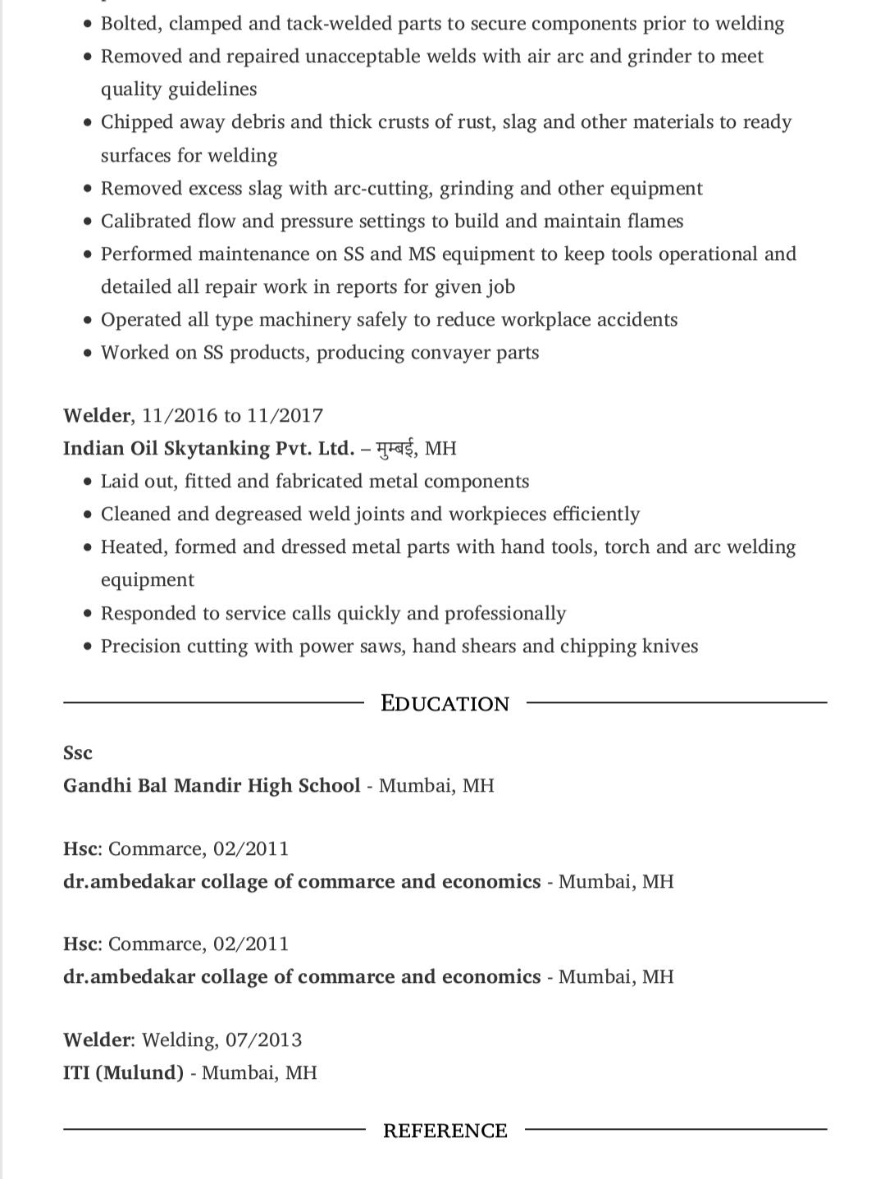
Sumit Nirbhavane
369/12 Patil Nirbhavane chawl, hall road, Kurla west
Mumbai, Maharashtra, 400070
(836)940-9240
sumitnirbhawane@gmail.com

Hiring Manager

Dear Hiring Manager,
Thank you for the opportunity to apply for the welder role at your company. After reviewing your job description, it’s clear that you’re looking for a candidate that is extremely familiar with the responsibilities associated with the role, and can perform them confidently. Given these requirements, I am certain that I have the necessary skills to successfully do the job adeptly and perform above expectations.
I am an efficient professional who has been consistently praised as efficient by my co-workers and management. Over the course of my 3- years career, I’ve developed a skills set directly relevant to the maintenance role you are hiring for, including manufacturing integration. Overall, I have consistently demonstrated technical and multitasking abilities in every aspect of my welder role at Core energy pvt. Ltd. and invite you to review my detailed achievements in the attached resume.
After reviewing my resume, I hope you will agree that I am the type of competitive candidate you are looking for. I look forward to elaborating on how my specific skills and abilities will benefit your organization. Please contact me at 9029005246 or via email at sumitnirbhawane@gmail.com to arrange for a convenient meeting time.
Thank you for your consideration, and I look forward to hearing from you soon.

Sincerely,
Sumit Nirbhawane

