CURRICULUM VITAE
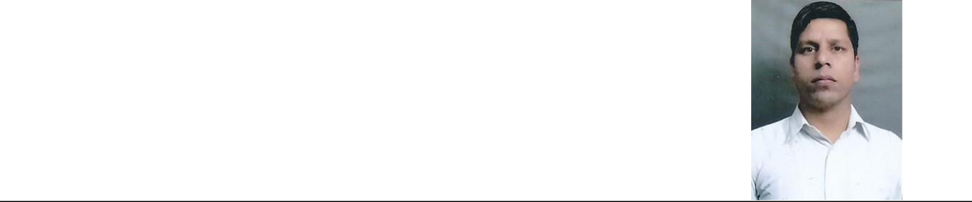

Jai Singh

Village . Vpo Kherki daula

District. Gurgaon

Contact No. 7701883718,9911605645 Email Id – singh.jai794@gmail.com

Career Objective:-

To work in as professional environment this can apply use my potential to this fullest ensuring both professional and personal growth.

Educational Qualification :-

- 10th Passed from Haryana Board with first Division
- 12th Passed from. Haryana Board with second Division

Technical Qualification:-

- I.T.I.Ref&Air conditioning (R&AC) from Gurgaon(2009)

- Diploma in Electrical Engg in 2014 Emperial Institute ( mundka delhi) EIMSR

Work experience:-

- Last worked with Red Fox Hotel in maintenance as a Electrician (MST).GSA(Guest service associate), East Delhi Plot No. 6, Community Center, Mayur vihar Phase III Delhi 110096 From 15.12.2009 to 08.02.2013

- Last working with Ninex city mart as a Electrician (MST) (Icon facilities) 1st April 2013 to 30.04.15.

- Last working with lemon tree hotels as (MST) Electrician from 1st august 2015, to 10st july 2017 Udyog vihar ,phase v gurgaon 122016 (HR)

- Presenity working with(03 /10/17 marketer plot n848 udyog vihar phase v Gurgaon) till date.
- Operation and Maintenance of L.T. Panels & D.G.Sets .

- All plumbing system repair & services.

- Fire Fitting system operating.

- Operation and maintenance of , Window A/C, Split A/C repair & Services.

Personal informations

Name | : | Jai Singh
Father’ s name | : | Shri Prithvi Singh
Date of birth | : | 7/sept/1983
Present Address | : Jai singh s/o Sh Prithvi singh Vpo Kherki daula,
 |  | Teshil – Manaser, Distt-gurgaon, Haryana (
 |  | India ) Pin code -122004
Contact no | : | 7701883718
Sex | : | Male
Marital status | : | Married
Nationality | : | Indian
Language known | : | Hindi & English
Date………..
Place……….. |  | Jai Singh

